Final Report
Team Smart Tow:
Trailer Towing Assistance System

Professor Schafer
May 6, 2008

John Strong
Jon Stembel
Jason Stoller
Brian Fischer
Fernando Contreras
Table of Contents
Introduction 2
Problem Statement 2
Proposed Solution 2
High Level Design Description 3
System Requirements 4
Meeting Design Expectations 8
Possible Future Enhancements 8
Future Design Improvements 9
Detailed Project Description 10
System Theory of Operation and Block Diagram 10
Driver’s Display 11
On-Trailer Monitoring Unit 13
Wireless Communications 13
Wireless Communications Protocol 14
Blind Spot Detection 15
Backup Ranging 18
Brake/Blinker Light Burn-out Detection 21
Outside Temperature Monitoring 22
In-Trailer Temperature Monitoring 23
Door Monitoring 25
Interfaces and Sensors 26
System Integration Testing 26
Users Manual and Installation Manual 27
Conclusions 36
Appendices 36

Introduction
In this project we seek to design and construct a trailer monitoring system that will provide the operator with useful safety related information about the trailer and its surroundings.

Problem Statement
The purpose of this system is to mitigate a number of safety risks associated with towing a trailer as well as to provide some convenient features for the operator. First, when a vehicle is towing a trailer its blind spots are significantly increased. As a result, normal driving maneuvers, such as changing lanes, become much more difficult and risky. Secondly, any situation that requires the operator to back up can prove hazardous because the operator has a large blind spot directly behind the trailer. If these blind spots could be eliminated or reduced, the safety risks associated with towing a trailer would also be reduced.
Other safety concerns when towing a trailer include the status of the trailer door as well as the temperature inside and outside of the trailer. For obvious reasons, it is important that an operator does not drive away with the trailer doors open. The temperature inside the trailer would be useful when carrying cargo, such as crayons or candle wax, which could be damaged by extreme temperatures. An outdoor temperature measurement would allow the driver to adjust for icy conditions.
Finally, a trailer operator does not currently have an indicator to show if the trailer brake lights and turn signals are working properly. Checking for burnt out bulbs must be done manually. Our goal is to minimize these safety risks by providing more information to the driver.

Proposed Solution
To help reduce the risk associated with these blind spots we propose to build a unified system of sensors to provide the operator with information about potentially hazardous conditions. The sensors will provide information to help mitigate the risks discussed in the Problem Statement above. The system will check the trailer’s blind spots for the presence of other vehicles, monitor the status of the trailer doors, measure inside and outside temperatures, monitor the brake & blinker lights, and help avoid collisions when backing up. In essence the system is a unified set of sensors which we will integrate together.
The operator of the trailer will receive this information via a wireless console kept in the cab of the towing vehicle. This console must not only display information, but must at times get the driver’s attention to alert him of unsafe conditions. Additionally, it may be convenient to provide the operator with the option to turn certain features on or off using this wireless console.

High Level Design Description
Figure 1: Block Diagram

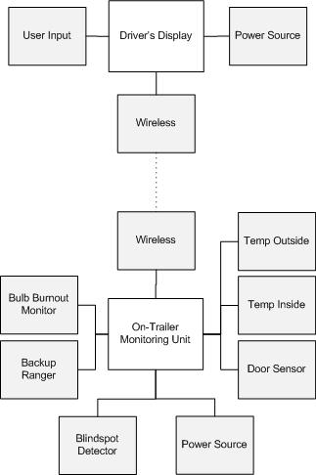
The entire system consists of two main units along with multiple external sensors. The first main unit resides on the trailer, and interfaces with all of the sensors placed on the trailer. This unit gathers the information from the sensors and then wirelessly transmits this data to the second main unit, the driver’s display.
The driver’s display resides inside the cab of the towing vehicle. It is the device through which the operator interfaces with the system. Not only does the driver’s display passively relay information, but it also actively gets the operator’s attention and alerts him of dangerous conditions. The driver is also able to change certain settings and turn certain features on and off using this display.

System Requirements
The only system requirements we did not meet from the list below pertain to weather. First, our packaging during the demonstration was not weather-proof as originally planned. Secondly, neither the ultrasonic blindspot detection nor the infrared backup ranging were tested in rain or snow. This is not to say that our system will not work in rain or snow, there simply needs to be further testing and field experiments to ensure the feasibility of our design in adverse weather conditions.

Overall System
- Clear, safe, intuitive relay of information to driver
- Appropriate alerts and alarms when necessary
- Easily operated and interfaced with
- Functions in all weather conditions
- Continuous operation
- Specific Features
  - Detect and indicate when car/truck/motorcycle is adjacent to trailer, and on which side
  - Detect and indicate temperature inside trailer
  - Detect and indicate temperature outside trailer
  - Detect and indicate status of trailer door (open/closed)
  - Assist in backing up trailer by providing backup ranging
  - Detect and indicate when (and which) brake/blinker lights are on
Driver’s Display
- Must display all sensor information
- Must receive user inputs
- Must alert driver of alarmed states when necessary
  - Audible and/or visual
- Wirelessly Communicate with On-trailer unit
  - Two-way communication, send and receive information
- Display information clearly
  - In sunlight
  - At night
- Interface with Driver easily and safely
  - Large buttons, text, indicators
- Sufficiently powered for continuous use

On-Trailer Monitoring Unit
The on-trailer monitoring unit will function as the control center for the system.
- Must connect to all the required sensors
- Must be able to handle short power losses (bad connection from truck to trailer)
- Must include ‘industry standard’ connections for both the trailer and the truck
- Must contain short range wireless communication
- Allow for plug and play connections for all peripherals
- Have a master on/off switch accessible to user
- Operate in all weather conditions (Excluding hurricanes, white-out conditions, etc.)
- Have a sufficient sampling rate to keep user up to date in real time
- Easily installed
- Fail-safe mode; trailer operates normally despite unit failure
- Provide accurate information to the display unit
Wireless Communications
- Reliable communication between on- trailer system and display up to 30 feet
- Reliable communication in all weather conditions
- Sufficiently low power to prevent RF pollution or interference with surrounding devices
- Low power to extend life of power source
- Low data rate to minimize system cost and complexity; high data rate not needed
- Signal must be able to penetrate through body of trailer and truck
- Relatively easy implementation of technology and software
- Transceiver chips must be sufficiently affordable to fit in budget
- Transceiver chip must fit size constraints of system

Blind Spot Detection
- Ambient sunlight (or headlights) should not affect functionality.
- Extreme temperatures should not affect operation.
- The device should withstand rain and snow.
- The sensor’s range should be at least 15ft. The width of a highway lane is 12ft.
- The apparatus should be directional; it should not detect objects that are located behind or in front of the trailer.
- The sensor must return correct readings even if the trailer is moving at fast speeds (80 mph max.)
- A sufficient number of sensors should be placed such that the entire blind spot region is covered.
  - The number of required sensors will depend on the trailer’s length, as well as on the smallest vehicle that should be detected.
  - The maximum trailer length supported by our design will be 15 ft, and the smallest detectable vehicle should be a motorcycle (about 5 ft long). Therefore, a minimum of three sensors will be required for each side.
- Interface with microcontroller should be simple.
- Software implementation should be simple.
- The color/nature of the detected vehicles should not affect accuracy.
- The material of the trailer should not affect operation.
- Accuracy is not paramount; the system must simply decide whether the lanes are empty or not.
- Low power
- Low cost
Backup Ranging
- Operable over a useful distance: 4-6 ft
- Accurate to ±3 in
- Durable
  - Withstand normal driving conditions
  - Withstand effects of weather
- Operable in all weather conditions (excluding white-outs, hurricanes, etc.)
- Color or reflective nature of the object behind trailer should not affect distance measurement
- User can turn off when not in use
- The sensor should easily interface with the microcontroller
- Inexpensive
- Easy to install
- Low Power
Brake/Blinker Light Burn-out Detection
- Detect when a brake light or turn signal bulb has burned out or failed
  - Measure current to bulbs, approximately 2-3A
- Give the operator information about which light is not on
Inside Temperature Monitoring
- Operational over range of -10°F to 110°F
- Accurate to ±3°F within above range
- Sample at least once every 5 minutes
- User can set a ‘safe temp range’; alarm sounds if temperature goes outside the set range
- Low power
- Low cost
Outside Temperature Monitoring
- Operational over range of -10°F to 110°F
- Accurate to ±3°F within above range
- Sample at least once every 5 minutes
- Turn on ‘icy roads’ icon when below 35°F
- Low power
- Low cost
Door Monitoring
- Operational over range of -10°F to 110°F
- Sample at least once every 2 seconds
- Door Open alarm
  - User can turn feature on/off
- Robust – not going to break after repeated slamming of door
- Reliable – gives accurate door open/closed information
  - ‘Door open’ event occurs when doors are completely misaligned
  - ‘Door open’ event DOES NOT occur when door is jostled, vibrated during travel
- Low power
- Low cost

Meeting Design Expectations

On-Trailer Monitoring Unit
Our final design was able to meet or exceed all of the desired specifications laid out in the low level design with one exception. In the LLD we stated that we would like the trailer unit to be reasonably weather-proof, in its current state our design is barely wind proof. A list of our specifications for the trailer unit is given below.
- Must connect to all the required sensors
- Must be able to handle short power losses (bad connection from truck to trailer)
- Must include ‘industry standard’ connections for both the trailer and the truck
- Must contain short range wireless communication
- Allow for plug and play connections for all peripherals
- Operate in all weather conditions (Excluding hurricanes, white-out conditions, etc.)
- Have a sufficient sampling rate to keep user up to date in real time
- Easily installed
- Fail-safe mode; trailer operates normally despite unit failure
- Provide accurate information to the display unit
Driver’s Display
The final version of the drivers display unit easily met all the design specifications that we included in our LLD. The display was very effective for relaying information to the driver from the trailer unit.

Possible Future Enhancements
Since our system is aimed at providing the driver with relevant safety information, there are some features that could be added to future revisions of the device which are beyond the current scope of our project.
Load Balance Sensing
In any closed trailer the ability to detect a shift in the load would provide the operator with valuable information. This information would be useful both while towing the load and during the loading/unloading process. While towing a trailer, a shift in the load could affect the behavior of the trailer and cause it to become unsafe. During the loading process this improvement could help the operator load the trailer evenly. Finally, being able to detect a shift in the load could warn the operator in the event that the load has shifted and is resting against the door of the trailer.

Complete Wireless Coupling
Being able to simply attach the trailer to the hitch and drive away without worrying about connecting any wires would simplify things for the operator. Ideally this revision to our system would allow the trailer system to sense the truck and power up and would then power down when the truck is detached from the trailer.

Future Design Improvements
If this project where taken on by in the future by another group there are a few things that could be improved rather easily. These improvements are mostly things that we considered building into our design but lacked either the time or budget to realize them.
Simplification of Ranging
Use the same type of sensor for the blind-spot and for back up ranging. This would make large scale assembly easier and parts management simpler. The reason our design used two different types of sensor was budget issues. The IR sensor was moderately less expensive, but had a much shorter range than that of the ultrasonic.
Power
Power the trailer unit with some type of power harvesting system, perhaps by using technology similar to the power harvesting done by the brake systems in hybrid vehicles. Another possibly viable power harvesting system is a kinetic motion system similar to the type found in many wrist watches. This type of system would be particularly well suited to a trailer due to the constant vibrations caused by imperfections in the road the trailer is traveling on.

Detailed Project Description

System Theory of Operation and Block Diagram
The entire system consists of two main units along with multiple external sensors. The first main unit resides on the trailer, and interfaces with all of the sensors placed on the trailer. This unit gathers the information from the sensors and then wirelessly transmits this data to the second main unit, the driver’s display.
The driver’s display resides inside the cab of the towing vehicle. It is the device through which the operator interfaces with the system. Not only does the driver’s display passively relay information, but it also actively gets the operator’s attention and alerts him of dangerous conditions. The driver is also able to change certain settings and turn certain features on and off using this display.

Driver’s Display
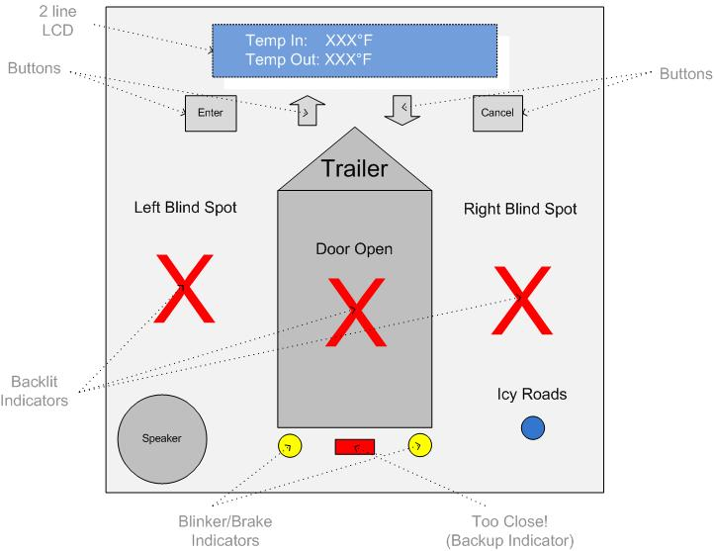
The driver’s display wirelessly communicates with the on-trailer unit and displays the current status of all sensors in an easily-readable and intuitive fashion. The unit provides both visual and audible feedback to the driver and will accept user input. The layout of the display unit is below:

Two software functions specific to the display unit are 1) Set Inside Temperature Range and 2) Silence Alarm. Both of these functions require input from the user and are outlined in flowcharts below:
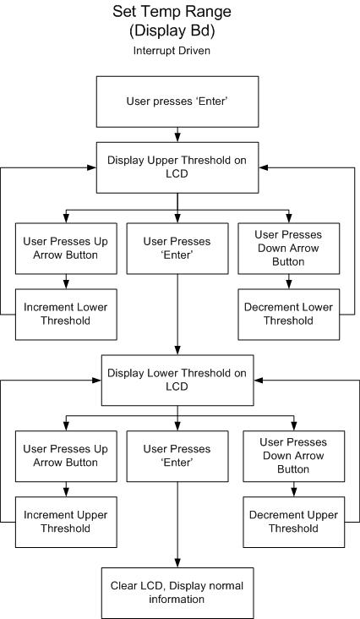
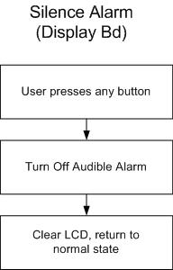

To reduce cost, the display board and the trailer board are identical boards; only the parts they are populated with are different. All the LEDs on the display board are driven by transistors as to not overload the current sourcing abilities of the microprocessor. All buttons on the display are interrupt driven. The backlight brightness and contrast on the LCD screen are controlled by two potentiometers on the side of the display board. A complete schematic of the display board is located in the appendices.

On-Trailer Monitoring Unit
The On-Trailer monitoring unit interfaces with all sensors, interprets their outputs and sends information to the display unit. This unit is responsible for all of the information gathering, a large part of the processing and then relaying the important information to the display unit. Some functions, such as the backup ranging, will be turned on or off using the display board. A complete schematic of the on-trailer monitoring unit is located in Appendix B. Each of the major functions of the on-trailer monitoring unit is discussed below:

Wireless Communications
Our wireless interface of choice is the Zigbee standard. We chose to use the module made by Maxstream (XBee), which communicates with the microcontroller using a standard UART interface. Familiarity with this interface due to extended use in assigned tasks in the fall semester played a role in this decision, as software design difficulty would be minimized. Additionally, the standard UART interface only requires two data lines from the microcontroller. The TX pin on the microcontroller runs to the DIN on the XBee chip and the RX pin on the microcontroller is connected to DOUT on the XBee chip. Power and ground traces are also provided, as well as traces for other status and flow control signals to and from the microcontroller. The partial schematic below shows all of the connections, which connect through the 5V to 3.3V level translators.
Partial Schematic: XBee chip connections through level translators
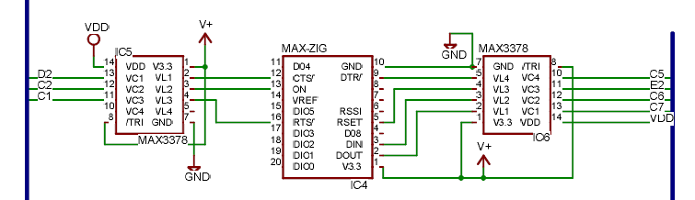

XBee connections to 18F4620 microcontroller
Pin on XBee | Function | Connection on 18F4620
CTS/ | Clear-to-send flow control | D2
ON | Module status indicator | C2
RTS/ | Request-to-send flow control | C1
DTR/ | Pin sleep control line | C5
RSET | Module reset | E2
DIN | UART Data in | C6
DOUT | UART Data out | C7

Due to the microcontroller’s interfaces with multiple subsystems, a decision must be made as to what logic level at which the microcontroller should be run. As most of the systems run at 5V, the microcontroller is run at 5V. However, the XBee chip runs only at 3.3V. Therefore, the interface between XBee and 18F4620 cannot be direct. The decision to use level translators for this interface made the most sense, as their implementation is very straightforward. As can be seen on the above schematic, the level translators take both 5V and 3.3V source voltages as well as ground, and use these to translate 5V to 3.3V from VC1-VC4, and vice versa. When connected properly, the level translators are a transparent part of the data flow between 18F4620 and XBee.
There are no interfaces between the XBee and other subsystems. This module has the sole function of transmitting the data communications of the 18F4620 on the same board, and receiving data communications from the other board. This highlights another reason for our decision to use ZigBee, and this particular part and package in particular: The XBee can be placed in “Transparent Operation” mode, in which it behaves and appears to the microcontroller very much as a wire replacement. No data packetization or preparation must be done by the microcontroller or in the software; the data can simply be shifted serially into the XBee, with attention paid to a few simple flow control signals.
The main concern in robustness of the subsystem is its ability to communicate through various barriers. Very particular to our application is the subsystem’s ability to successfully communicate with another board through multiple layers of metal, plastic, cloth, flesh, and whatever outside environment conditions are possible. The system was tested by sending test messages between boards at various distances and through different barriers, as listed above. Finally, the most telling test is whether communication is realized correctly when the entire system is tested with a truck in actual conditions. While it was impossible for us to create any weather condition that could possibly be encountered, we are reasonably confident from the conditions that we were able to create to test in that the subsystem is robust enough to provide reliable communication in all but the most extreme conditions.

Wireless Communications Protocol
The communication between the trailer board and the display board takes place over the Zigbee chips described above. After choosing a specific channel and PAN ID to operate on, we chose to use the Zigbee chips in ‘pass-through’ mode. As the name implies, in this mode the Zigbee chips simply transmit all the messages they receive through their UART connection as if there were solid wires between the two chips.
Each message sent across by the trailer board is initiated by sending across the unique ‘begin message’ byte, 0x7E. Then, an ‘identifier’ is sent across to indicate what type of data is being transmitted. Finally, the actual data is sent across the wireless link. Therefore, each transmission consists of three bytes of information, the begin message byte, the identifier byte and the data byte. The table below shows the standard we chose:
Unique ‘Beginning of Message’ | Identifier | Data
0x7E | Lights: 0b00000000 | Explained below
 | Backup: 0b00000001 | Backup range in inches
 | Temp In: 0b00000010 | Temp in degrees F
 | Temp Out: 0b00000011 | Temp in degrees F

Lights Data
bit 7 | bit 6 | bit 5 | bit 4 | bit 3 | bit 2 | bit 1 | bit 0
reserved | R Blink | L Blink | reserved | L Blind | R Blind | Icy | Door

After a message is received by the display, an acknowledgement (one byte, 0x01) is sent to the trailer board. If the trailer board does not receive an acknowledgement from the display, it will attempt to re-send the message nine more times before moving on.
If the display does not receive any communication from the trailer for more than approximately five seconds, it will flash the blindspot and blinker LEDs and display ‘Lost Comm with Trailer’ so that the user is adequately notified of the situation.

Blind Spot Detection
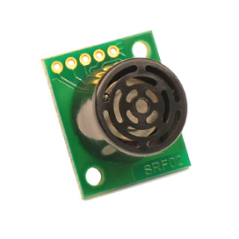
For blind spot detection, two Devantech SRF02 ultrasonic sensors were utilized. One sensor was attached to each side of the trailer to check for cars in the trailer’s blind spot. The sensors communicate with the microcontroller using a standard I2C interface. Each sensor returns a distance measurement in inches. Based on the returned values, the microcontroller decides whether there is a car on each adjacent lane.

Connections:
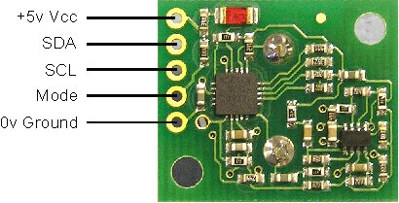
As shown, the SRF02 sensors have 5 pins of interest. The VCC and Ground pins were wired to 5V and 0V respectively. SDA and SCL represent the data and clock lines used for I2C operation. Each has a 1.8k pull-up resistor to 5V. The “Mode” pin was left unconnected.
Schematic:
Partial Schematic: Blind Spot Sensors (Trailer Bd)
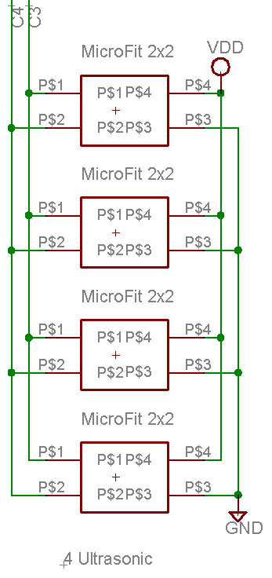
Registers:
Location | Read | Write
0 | Software Revision | Command Register
1 | Unused (reads 0x80) | N/A
2 | Range High Byte | N/A
3 | Range Low Byte | N/A
4 | Autotune Minimum – High Byte | N/A
5 | Autotune Minimum – High Byte | N/A

As shown, the SRF02 sensors have 6 registers. The register at location 0 must always be written to in order to start a ranging session. One must also write to the same register in order to read the returned distance values. The registers at 2 and 3 contain the high and low bytes of the most recent ranging. For our particular application, the remaining registers are not needed.
Commands:
There are multiple commands that can be used to initiate a ranging. However, we only used command 0x50, which tells the SRF02 sensor to start the ranging and return the value in inches.
Basic I2C process:
- Write command 0x50 to the register at location 0. This initiates the ranging.
- Wait 65 mS. This is the time taken by the sensor to complete the ranging process.
- Write command 0x51 to the register at location 0. This tells the sensor that one wants to read from it.
- Read registers 2 and 3 to obtain the ranging results.
Making decisions:
Based on the values returned by the sensor after each reading, we had to decide whether there was a vehicle in each adjacent lane:
Left blind spot:
If (distance (left) < 120 inches)
There is a vehicle! The corresponding LED should be ON.
Else
There are no vehicles on the left side. The LED should remain OFF.

Right blind spot:
If (distance (right) < 120 inches)
There is a vehicle! The corresponding LED should be ON.
Else
There are no vehicles on the right side. The LED should remain OFF.

Testing:
The ultrasonic sensors were tested by placing an object at various distances from the sensor and displaying the distance read by the sensor on the LCD screen. The distance was accurate to within a few inches. The appropriate indicator LEDs lit up when the vehicle is placed within the specified threshold distance.

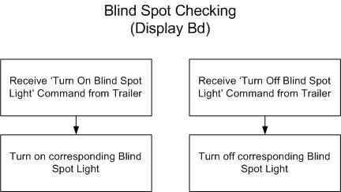
Software diagrams for Blind spot Checking:
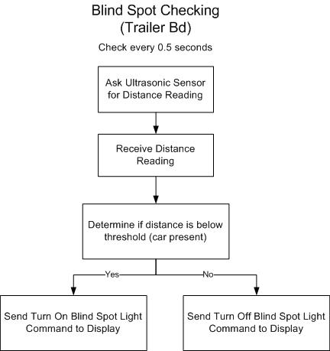

Backup Ranging
The system requirements denote that a trailer’s distance to an object from behind must be made available to the driver in real time. The selected sensor must be cost effective, reliable, accurate, and easy to install. The chosen technology to accomplish this task is infrared. Sensors produced by SHARP are able to meet the requirements of the project. The small package size allows for easy and strategic placement of the sensors without compromising durability. The sensors have some simple onboard computing that returns a voltage that is proportional to the distance an object is away from the sensor. A simple A/D conversion of the output voltage allows for an accurate (±2”) backup range to be returned to the driver of the tow vehicle. The sensor requires three signals to operate correctly (Power, GND, Signal).

Partial Schematic: Backup Sensors
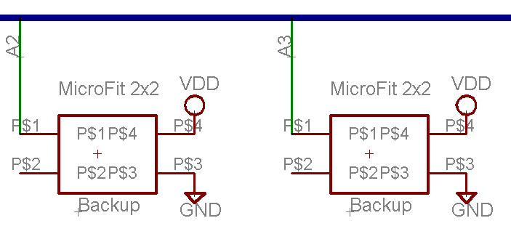
The use of two IR sensors in the design allows for two points of information to be obtained processed and returned to the driver as more accurate information. The auxiliary line from the tow vehicle is sampled once every ten times through the main program. This allows the program to know when the vehicle is in reverse. If this is the case, both IR sensors begin returning a voltage to A/D converters on the microcontroller and converted to a range in inches through a mathematical relationship. The values of each sensor are compared and the shortest distance is displayed to the driver. This is to account for potential uneven surfaces such as a corner of a building. This is illustrated in the following diagram:
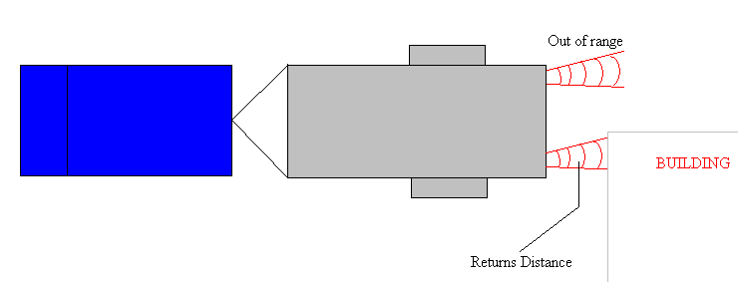
The sensors do not have the ability to reliably measure distances of under eight inches. When the trailer is under eight inches away from an object the string “TOo CLOSE” is displayed to the driver and two red LED’s provide further warning of close objects. When the driver is safely out of this range, normal operation is returned. The system does not measure a correct distance until an object is within 5’3”; while the closest object is outside that range, the max distance of 5’3” is displayed. When the backup mode is enabled, all other functions of the system are suspended until the driver is done backing up and takes the tow vehicle out of the reverse gear. The system was tested for maximum distance using a simple board that was held at different distances from the sensor. Different surfaces were used which ranged from very reflective white paper to rough black cloth surfaces. The sensor returned consistent data regardless of surface type or color.

Backup Flowchart
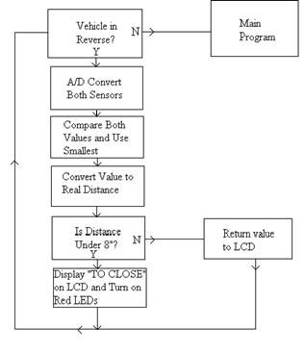

Brake/Blinker Light Burn-out Detection
To detect when a brake light or blinker has burned out, we will monitor both the current and the voltage on each brake/blinker line. Shunt resistors have been placed in-line with the blinker and brake lines in order to monitor the current to each bulb. When the voltage on one line goes high, the microprocessor will interrupt and measure the current through that line. If the voltage across the shunt resistors is above 0.05V, the light is working and the indicator on the display will blink. If the voltage across the shunt is below that threshold, the light is burned out and the corresponding indicator light will not turn on. The lights on the display board will mirror the actual lights on the trailer. For instance, if the left turn signal bulb on the trailer is burned out, the indicator on the display will not turn on when the driver signals for a left turn with the truck’s blinker.
Partial Schematic: Bulb Burnout Monitoring
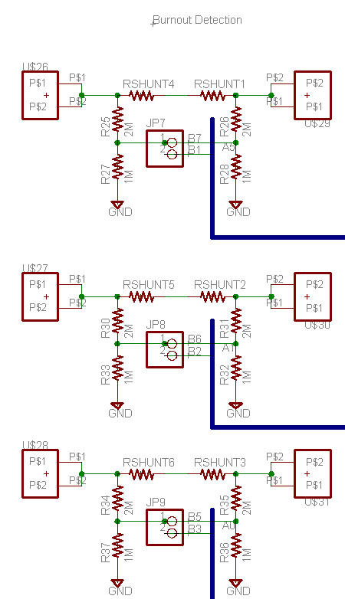

Software diagrams for rear light checking:
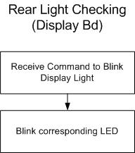
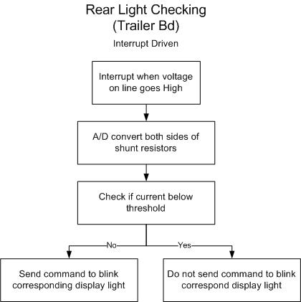

Outside Temperature Monitoring
The outside temperature monitoring is performed using a digital temperature sensor which communicates with the microcontroller using the I²C standard two-wire communication protocol. The entire trailer board is located outside the trailer, so this chip is mounted on and connected directly to the trailer pcb. The Display board prints this temperature to the LCD and lights the ‘Icy Conditions’ indicator if the temperature is below 32°F.
Partial Schematic: Outdoor Temperature Sensor
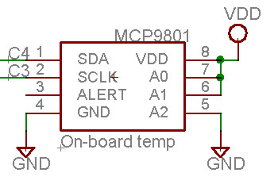
To test the accuracy of the sensor, we compared the sensor’s readings against a thermometer from the Learning Center. The sensor performed reasonably well (within ±3 degrees) when heated up by hand and with a heat gun.

Software diagrams for Outside temperature checking:
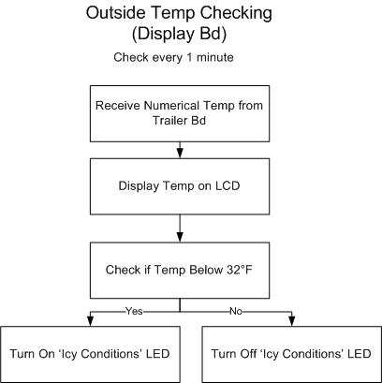
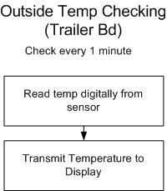

In-Trailer Temperature Monitoring
The inside temperature monitoring is accomplished with an analog temperature sensor. The initial design called for the use of the same digital temperature sensor as the outdoor temperature monitoring, but it was experimentally found that the digital chip was not able to operate on the end of a 10ft wire. The digital temperature chip was not able to acknowledge its address nor transmit data across such a long line. We hypothesize that the chip’s output was not able to drive the data line low as a result of the large RC term introduced by the presence of such a long wire. Despite lowering the value of the pull-up resistors and ensuring the rise and fall times of the clock pulses were within the I2C specification with an oscilloscope, we were unable to communicate with the sensor on the end of the wire. Therefore, we defaulted to using an analog part which is less accurate, but still meets our product’s needs.
After the microcontroller A/D converts the output of the in-trailer temperature sensor to a temperature in degrees F, the measurement is sent across to the display. The display board will then print the temperature on the LCD screen, and alarm the user if the in-trailer temperature is outside the defined alarm limits.
The testing of the in-trailer temperature monitoring was identical to that of the outside temperature monitoring.

Software Diagrams for In-trailer Temperature Checking:
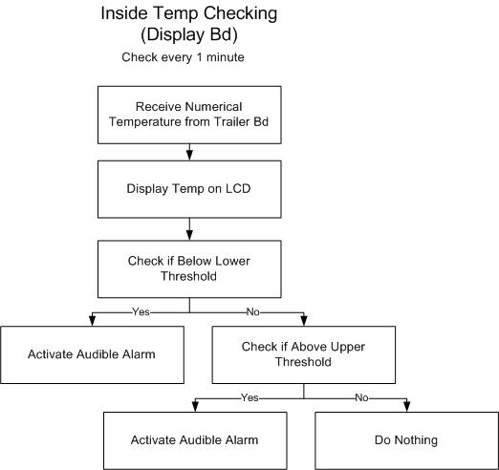
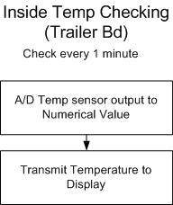

Door Monitoring
The monitoring of the trailer door is accomplished with a magnetic sensor manufactured by Cherry. This device is a switch which is closed when a magnet is present and open when the magnet is taken away. The software will be interrupt driven and will alert the user when the door is ajar.
Partial Schematic: Magnetic Sensor
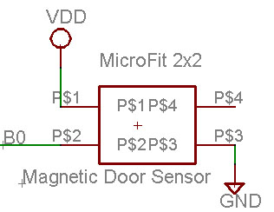
The door sensor was tested by placing the magnet close to the sensing device, within the device’s spec and verifying that the door open alarm was silent. The magnet was then removed to verify that the door open alarm turns on. Once the alarm is activated any button silences the alarm and resets the LCD. The Door LEDs always indicate the true status of the door, whether the display is in an alarmed state or not.
Software diagrams for Door monitoring:
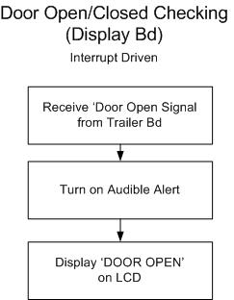
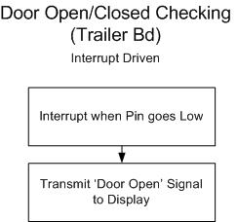

Interfaces and Sensors
The size of the I²C pull-up resistors was determined experimentally. In order to conform with the standard I²C specification, the rise time of a signal needs to be in the range of 20-300 ns. We gradually reduced the value of our pull-up resistors from 1.6kΩ down to 600Ω to meet this requirement of the specification. Despite the lowering of the pull-up resistors, the remote in-trailer temperature sensor which was initially designed to operate using the I²C protocol would not function properly. In retrospect, we should have additionally verified the fall time of each signal to be in the same range of 20-300 ns. Because each line is normally high and each chip needs to ‘drive’ the communication lines low, the fall time is in some senses more crucial to the communication. The ultrasonic sensors, which also operate on the I²C protocol, did communicate reliably with the microcontroller despite the length of the wire they were connected with.

System Integration Testing
There is very little interaction between our various subsystems. Most of the subsystems in the trailer half of the entire system are simply sensors or arrays of sensors that return numeric (either digital or analog) values, which are then interpreted or processed by separate functions within the main trailer board program. Similarly, the subsystems on the driver board mainly concern making decisions with data gathered and transmitted from the trailer board, displaying information and taking inputs from the user. Most systems integration takes place within the software, as determinations are made as to how to run all of the sensor systems simultaneously. The only major system integration of any kind is wireless communication between the trailer and driver boards, and the bulk of this is realized simply by using the “Transparent Operation” mode of the XBee chip.
Therefore, the system is integrated and tested one subsystem at a time. Initially, each system was breadboarded on a proto board separately to test the functionality of each. After this was verified, the subsystem processing software and associated routines were added into the main program one at a time in order to work out all the possible bugs in the program. The entire system was finally realized on a proto board and with ZigBee-capable boards used in the class in fall semester. Events such as turn signals blinking and the vehicle being put into reverse were simulated by connecting buttons between power/ground and the various detector circuits in order to provide the high-low transitions that our system depends on for providing this information to the driver. Additionally, sensors were tested with lengths of cable to determine if the sensor systems would work properly at distance from the microcontroller. The real challenge of integration came in designing circuit boards to house all of the subsystems and then connecting all of them once we had the boards. The only real way of testing the integration of subsystems was to connect everything and work out bugs in the software.
The successful testing of communication and information display from the box for the user confirms that we have met overall system requirements of safe and simple display of information to the user, as well as ease of operation and interface, and warnings/alerts when appropriate. The bulk of the functionality of the display board is accounted for in the software, and thus when the software successfully integrates the various sensor subsystems, this successfully meets our system requirements for the system interface. Testing of the overall system also confirms our requirements of ease of installation and accessibility by use of “industry standard” connectors. The need for reliable communication is met in the testing of the actual system with a vehicle and the associated trailer to be monitored. The integration of the systems does not play as pivotal of a role in meeting design requirements for this project as much as design and implementation of subsystems. Successful testing of the overall system confirms the software integration of these multiple sensor subsystems, each of which was designed and built to specification.

Users Manual and Installation Manual
Installation:
Before installing your new Smart Tow Trailer System, make sure that you have all the required components:
 | Item # | Quantity | Description
 | 1 | 1 | Driver’s display (the box including the graphic display and the 4 buttons)
 | 2 | 1 | Trailer box
 | 3 | 2 | Ultrasonic sensors
 | 4 | 2 | IR sensors
 | 5 | 1 | Remote Temperature sensor
 | 6 | 1 | Door sensor
 | 7 | 1 | Trailer connector (Male plug)
 | 8 | 1 | Trailer connector (Female plug)
 | 9 | 1 | DC Converter

Once this has been verified, you may proceed:

Step #1: Cautiously insert the male connector plug (coming out of the trailer box) into the female socket of the truck. Use the following illustrations for reference:

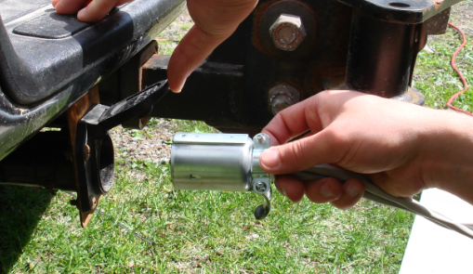
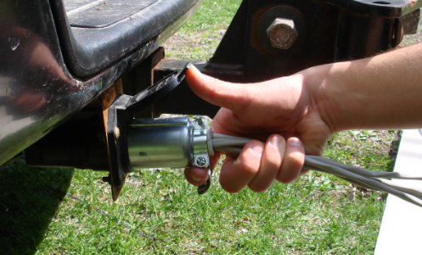
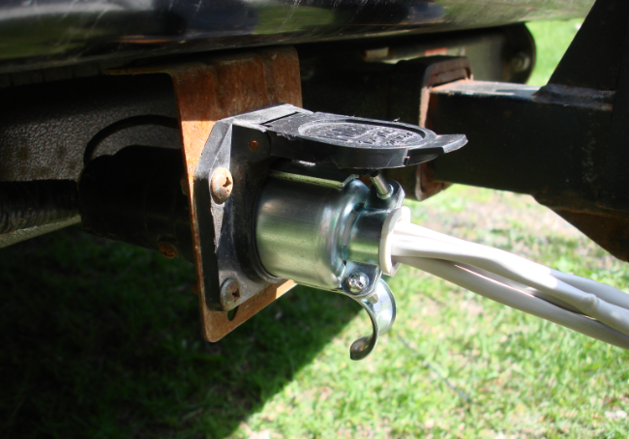

Step #2: Now, insert the male connector plug (coming out of the trailer itself) into the female connector on the trailer box. The following photos show how this should be performed:
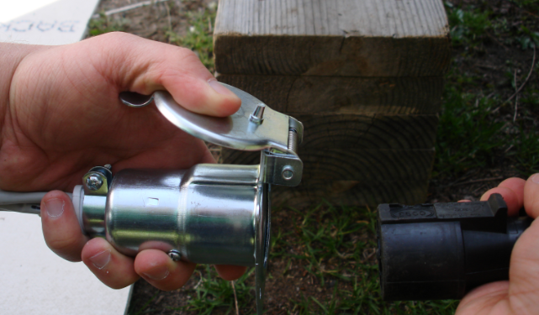
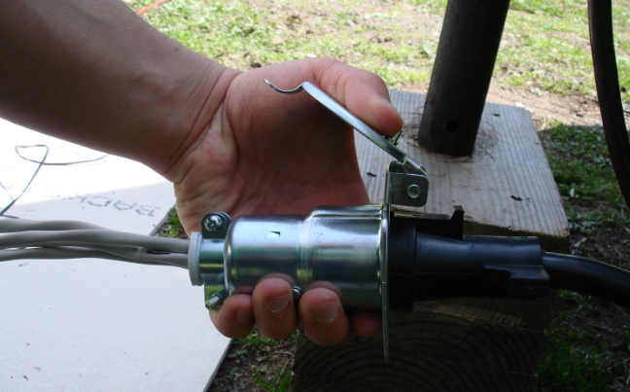
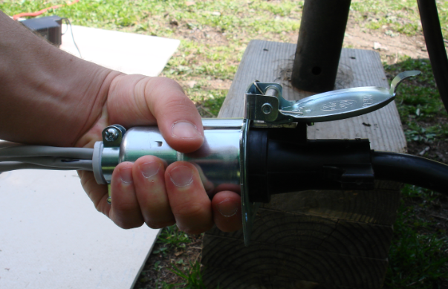

Step #3: Attach one ultrasonic sensor on top of the trailer’s left wheel cover. Ensure that it is aimed at a 45 degree angle backwards such that the sensor is able to detect vehicles in the trailer’s blindspot. Verify that the sensor is connected to the trailer box.
Step #4: Repeat the previous process (Step #3) for the other ultrasonic sensor. This time, attach it on top of the trailer’s right wheel cover. Again, do not forget to aim the sensor at a 45 degree angle as previously described. Verify that the sensor is connected to the trailer box.
Step #5: Attach one of the IR sensors to the back of the trailer (left side). Make sure that it is facing straight backwards so that the backup ranging will operate properly. Check that it is connected to the trailer box.
Step #6: Repeat the previous process (Step #5) for the other IR sensor. This time, make sure that it is firmly fixed on the right side of the back of the trailer. Check that it is connected to the trailer box.
Step #7: Place the temperature sensor inside of the trailer. It is highly advised that you drill a small hole on the trailer so that the sensor can go through. Verify that the sensor is connected to the trailer box.
Step #8: Now, get the door sensor. As you can tell, this sensor has two parts. One part (the one that is not connected to the wire) should be firmly attached to the actual trailer door. The other part (the one connected to the wire) should be secured right next to it (< 1 cm separation) but not on the door itself.
Step #9: Secure the trailer box onto the trailer.
Step #10: Now, get the driver’s display (the one with the screen and the 4 buttons) and bring it inside the truck. Power the device using the DC converter provided. Use the following images for reference:

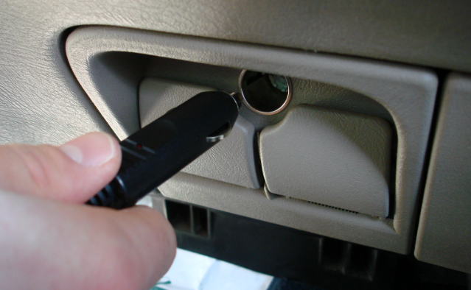
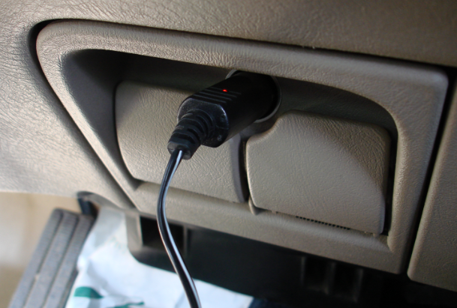
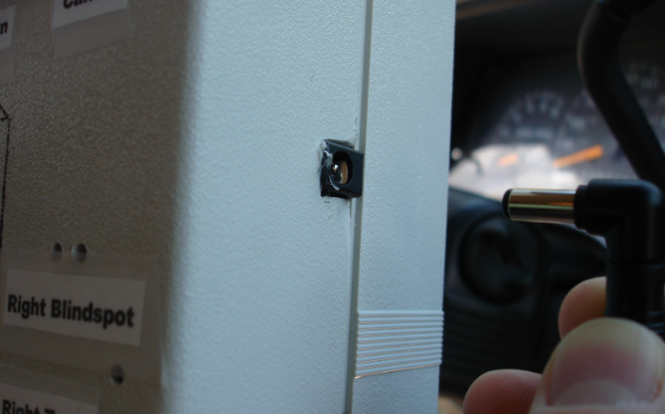
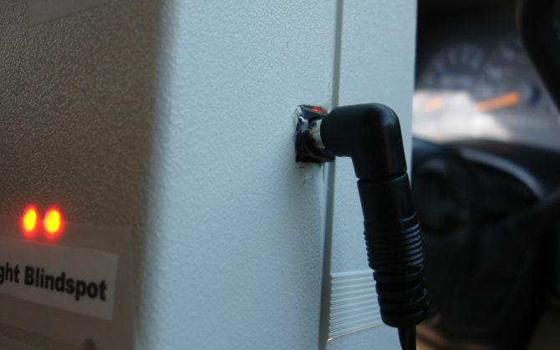
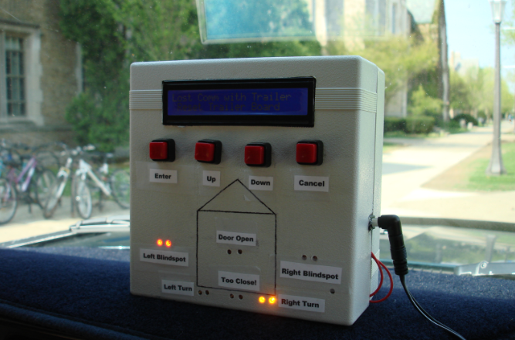

Step #11: At this point, the installation should be complete. Verify that all of the sensors are firmly secured to the trailer and that they are connected to the trailer box.
Step #12: Before using this product, verify the operation of all sensors. To verify the operation of the blindspot sensors, have a friend stand in front of the sensor, less than 10ft away. To verify the operation of the backup sensors, have a friend hold a piece of cardboard or poster board in front of the backup sensors and vary the distance while you check the readings for accuracy. Checking of the door sensor, temperature sensors and burnout indicators are self-explanatory.
Setup:
The only feature that must be setup/configured involves the monitoring of the temperature inside of the trailer. The user is allowed to specify the range of temperatures that should be tolerated. If the temperature goes outside the bounds, an alarm will go off. To set the minimum and maximum temperatures:
- Press the “Enter” button.
- The LCD will display the current maximum temperature. Use the up and down arrows to change the value.
- If you are satisfied with the newly selected maximum temperature, press the “Enter” button. Else, press the “Cancel” button to restore the maximum temperature to its previous value.
- The LCD will now show the current minimum temperature. Use the up and down arrows to change the value.
- If you are satisfied with the newly selected minimum temperature, press the “Enter” button. Else, press the “Cancel” button to restore the minimum temperature to its previous value.
- The LCD will return to its original state, displaying the actual temperature inside and outside the trailer.

Is the system working properly?
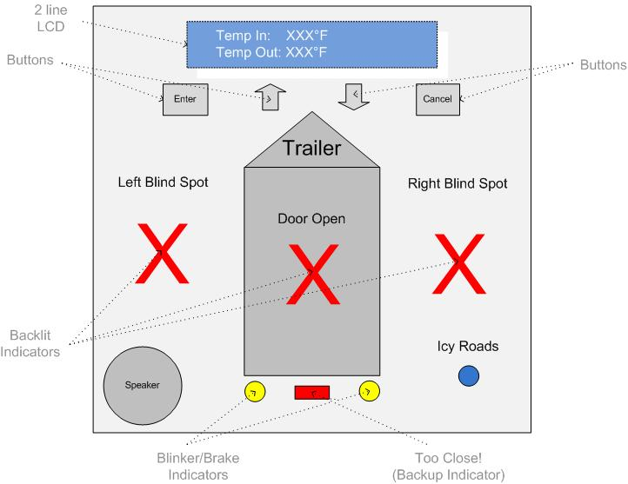
The following section describes the product when it is operating properly. If your system behaves differently, refer to the Troubleshooting section:
Initial State:
- After the Driver’s Display has been powered, an animated message should appear on the LCD. Moments later, the temperature inside and outside the trailer should be displayed.
Temperature Monitoring:
- The LCD should display accurate values for the temperatures inside and outside the trailer. If either value appears to be “way off”, there is a problem.
- If the outside temperature goes below 32ºF, the blue LED should be ON.
Blindspot detection:
- The left red LED of the Driver’s Display should be ON when there is a car on the trailer’s left blindspot, and it should be OFF otherwise.
- The right red LED should be ON when there is a car on the trailer’s right blindspot, and it should be OFF otherwise.
Door:
- The LED on the center of the display should be ON when the door is opened. An audible alarm should also be heard. To turn off the sound, press any of the four buttons on the display.
- The LED on the center of the display should be OFF when the door is closed.

Brakes:
- If the driver presses the brakes, the two yellow LEDs should be turned ON simultaneously. When the brakes are released, both yellow LEDs should be turned OFF.
Blinkers:
- If the driver activates the left turn signal, the left yellow LED should blink intermittently.
- Similarly, if he activates the right turn signal, the right yellow LED should blink intermittently.
- If the bulbs are burned out, the indicators will NOT blink.
Backup Ranging:
- If the driver puts the truck in reverse, the LCD should display the distance (in feet and inches) from the back of the trailer to its nearest object.
- If this distance goes below 8 inches, the LCD should display “Too close!” The lower red LED should also be turned ON.
Lost communication: If the LCD displays that “communication has been lost with the trailer” the following could have occurred:
  - The Driver’s Display and the trailer box are too far apart, making it impossible for successful wireless communication to occur.
  - The trailer box has lost power and is disconnected.

A summary of the proper operation of the product is shown in the following table:
Event Description | Red LED (left) | Red LED (right) | Red LED (center) | Red LED (bottom) | Yellow LED (left) | Yellow LED (right) | Blue LED | Speaker/Buzzer
Left lane occupied | ON
Right lane occupied |  | ON
Door open |  |  | ON |  |  |  |  | ON
Backup ranging mode |  |  |  | ON*
Left Turn |  |  |  |  | blinking
Right Turn |  |  |  |  |  | blinking
Brakes pressed |  |  |  |  | ON | ON
Outside temperature below 32º F |  |  |  |  |  |  | ON
* The Red LED (bottom) is enabled during backup ranging mode ONLY if the trailer is “too close” (< 8 inches) to the nearest object behind it.
Note: This table does not include the proper output of the LCD screen.

Troubleshooting:
- If any aspect of your product is not working as described in the previous section, follow these steps:
  - Make sure that all the sensors are properly connected to the trailer box.
  - Verify that the trailer connectors (male & female plugs) are connected as specified in the instructions manual.
  - Reset the trailer box.
  - Unplug and plug the DC power source to the Driver’s Display.
- If this did not solve the problem, there may be problems with the product’s hardware (sensors, boards, etc.). Call 1-800-SMART-TOW for assistance.

Conclusions
We set out to design and implement a trailer monitoring system that would provide the driver with usable real time information about the state of the trailer being towed; we now have a working prototype that does exactly that. However, while the system does perform to specifications, before the system could be used in a real world application there are several packaging issues that would need to be addressed. The weather-proofing issue is a good example; another would be a more robust installation of the sensors which are currently attached to the trailer using duct tape. There are a few more issues of this nature that are all mechanical and thus fall outside the realm of our expertise.

Appendices
1) MS Project File: Attached
2) Complete Hardware Schematics: Attached
3) Complete Software Listing: Attached
4) Links to spec sheets: Below

Links to data sheets
Microprocessor: Microchip PIC18F4620 http://ww1.microchip.com/downloads/en/DeviceDoc/39626d.pdf
MaxStream XBee (Zigbee) Chip
http://ftp1.digi.com/support/documentation/manual_xb_oem-rf-modules_802.15.4_v1.xAx.pdf
Level Translators (between Microcontroller and Zigbee)
http://datasheets.maxim-ic.com/en/ds/MAX3372E-MAX3393E.pdf
LCD
http://crystalfontz.com/products/2402a/datasheets/803/CFAH2402ATMIJP_v1.0.pdf
Buzzer
http://www.projectsunlimited.com/audioproducts/movieclips/products/drawings/SMI-1324-TW-5V-2-R.pdf
Shunt Resistors
http://www.ohmite.com/catalog/pdf/lvk.pdf
Ultrasonic (Blindspot) Sensors
http://www.acroname.com/robotics/parts/R287-SRF02.html
Magnetic Door Sensor
http://www.cherrycorp.com/english/sensors/pdf/MP2019_Series.pdf
http://search.digikey.com/scripts/DkSearch/dksus.dll?Detail?name=CH413-ND
Infrared (Backup) Sensors
http://acroname.com/robotics/parts/R144-GP2Y0A02YK.html
Digital Temperature Sensor
http://ww1.microchip.com/downloads/en/DeviceDoc/21909b.pdf
Analog Temperature Sensor
http://ww1.microchip.com/downloads/en/DeviceDoc/21498C.pdf

Average highway width is 12 ft: http://www.fhwa.dot.gov/ohim/hs01/hm33.htm

